Download the file from <https://s3.amazonaws.com/anil-cloudenabled/nexus-jenkins-plugin-1.0.2-02.hpi>

**Step 1 :**  **Login to Jenkins > manage Jenkins**

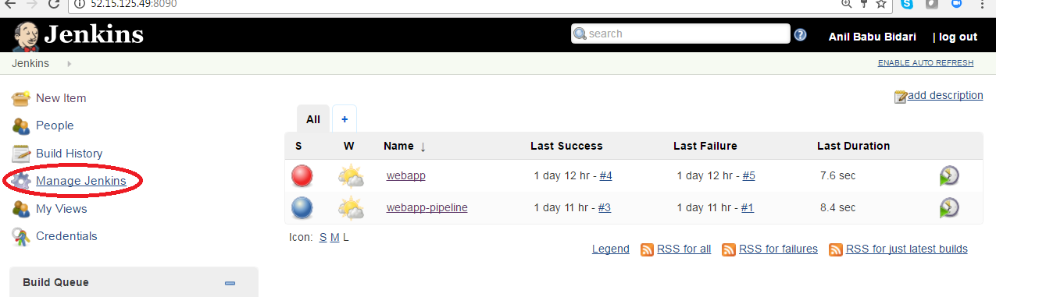

**Step 2 :**  **click manage plugins**

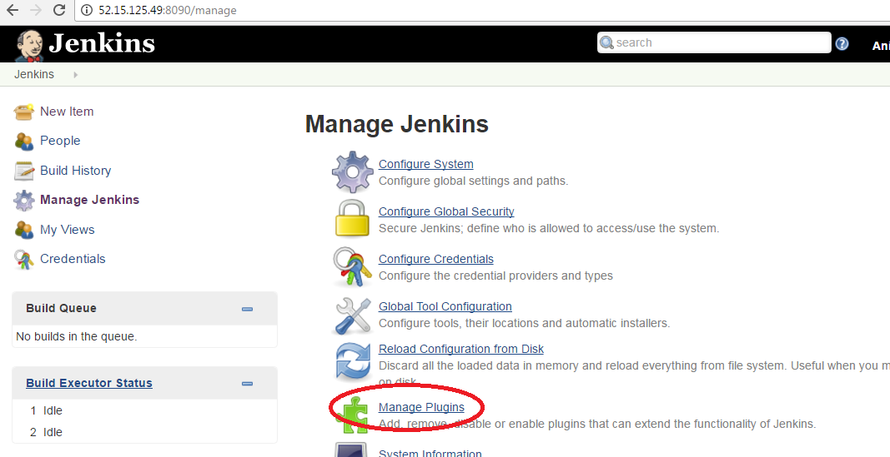

**Step 3 :**  **click on Advanced**

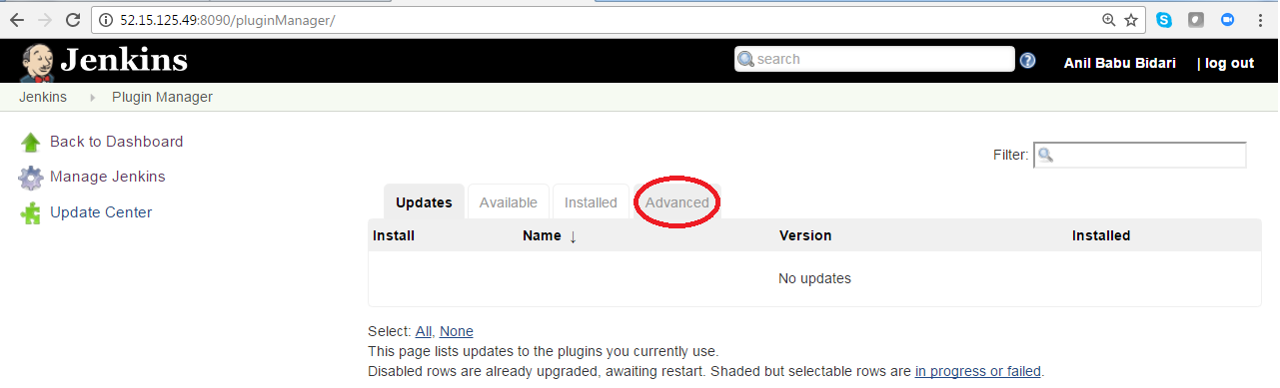

**Step 4 :**  **Click on choose file browse for nexus-jenkins-plugin-1.0.2-02.hpi**

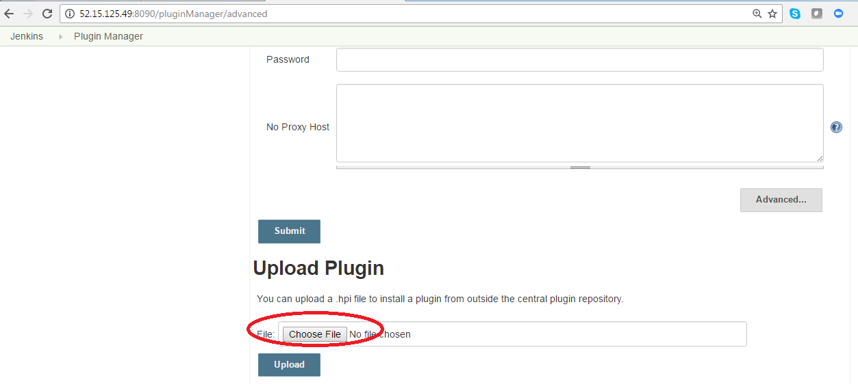

**Step 5 :**  **Click on Upload**

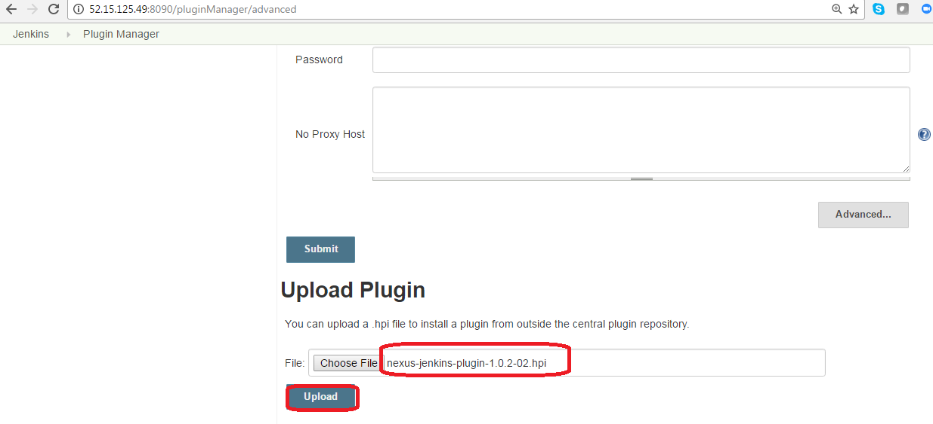

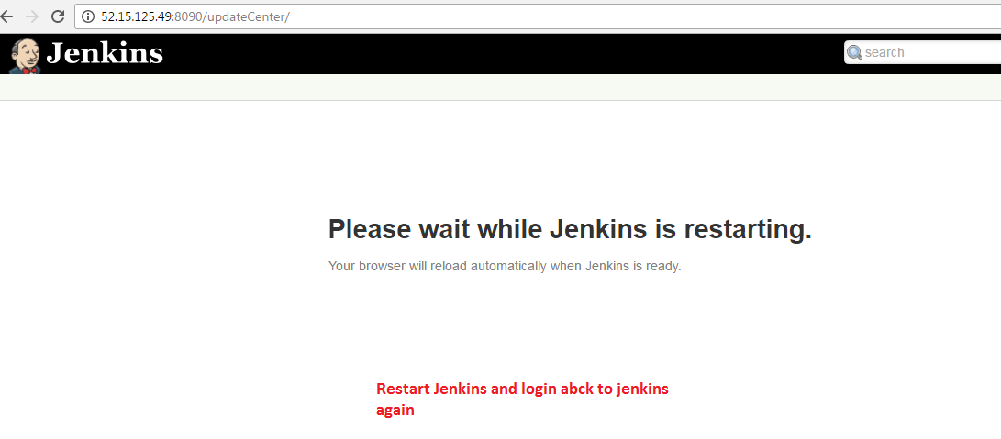

Pipleine script ( copy and paste below)

node ('node01') {

stage 'checkout'

git 'https://github.com/cloudenabled4/https-github.com-g0t4-jenkins2-course-spring-boot.git'

dir('spring-boot-samples/spring-boot-sample-web-ui/')

{

stage 'compile,test and package'

sh 'mvn clean install -DskipTests package'

stage('SonarQube analysis')

withSonarQubeEnv('sonarcube') {

// requires SonarQube Scanner for Maven 3.2+

sh 'mvn org.sonarsource.scanner.maven:sonar-maven-plugin:3.2:sonar'

stage 'archive'

//archive the jar file

archiveArtifacts 'target/*.jar'

stage ('upload .jar to nexus')

sh 'curl -v -u admin:admin123 --upload-file target/spring-boot-sample-web-ui-1.4.0.BUILD-SNAPSHOT.jar http://52.60.89.53:8081/nexus/content/repositories/releases/'

stage 'deploy jar on node01'

sh 'java -jar target/spring-boot-sample-web-ui-1.4.0.BUILD-SNAPSHOT.jar'

}

}

}

